Report

Screenshots:

1. **Size of array is 2000**

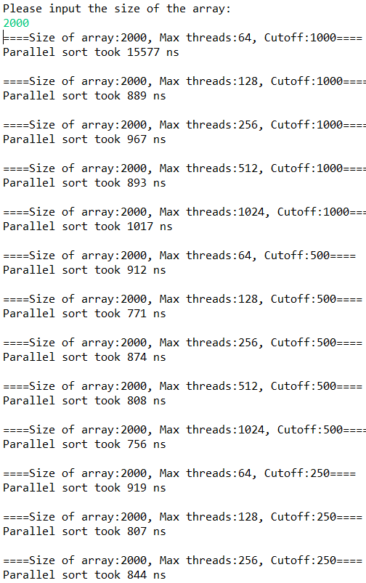

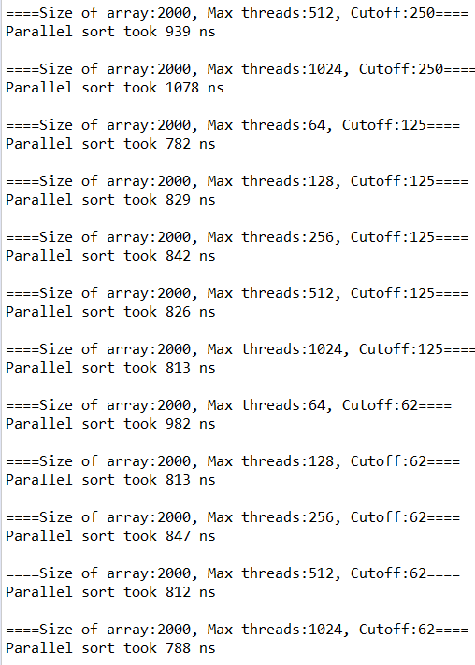

**Size of array is 10000**

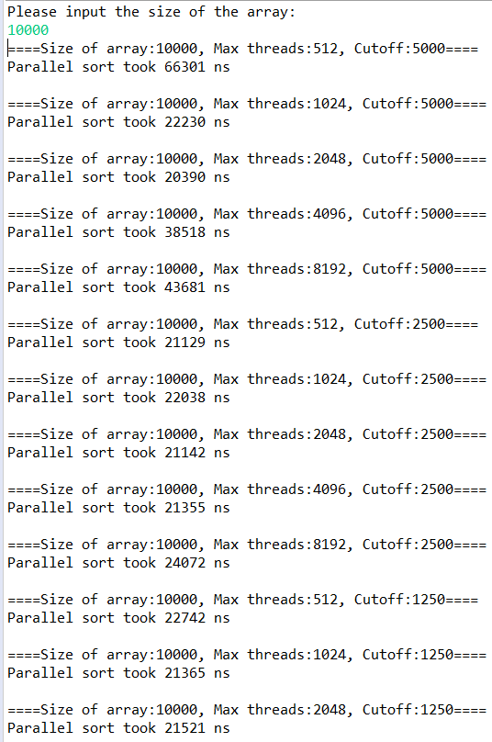

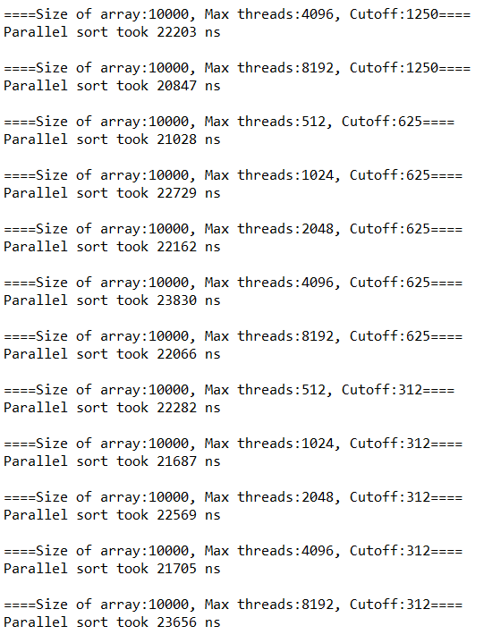

**(3)Size of array is 20000**

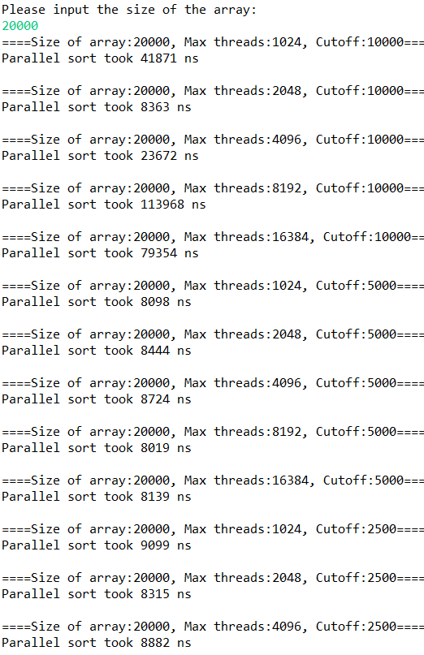

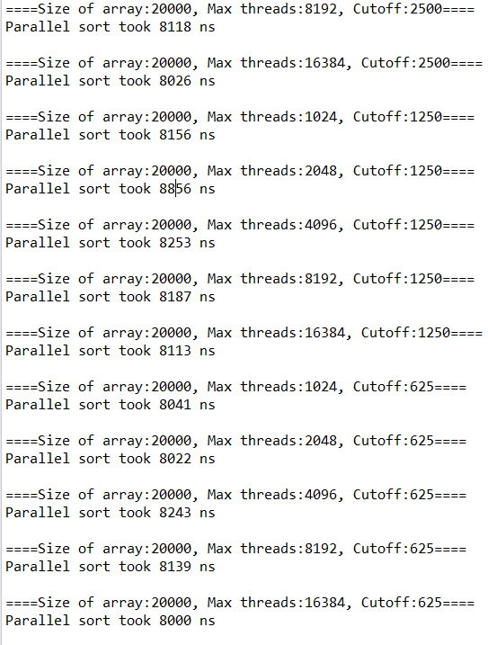

**Comparison:**

1. **Size=2000(ns)**

|  |  |  |  |  |  |
| --- | --- | --- | --- | --- | --- |
| Max threads  Cutoff | 64 | 128 | 256 | 512 | 1024 |
| 1000 | 15577 | 889 | 967 | 893 | 1017 |
| 500 | 912 | 771 | 874 | 808 | 756 |
| 250 | 919 | 807 | 844 | 939 | 1078 |
| 125 | 782 | 829 | 842 | 826 | 813 |
| 62 | 982 | 813 | 847 | 812 | 788 |

1. **Size=10000(ns)**

|  |  |  |  |  |  |
| --- | --- | --- | --- | --- | --- |
| Max threads  Cutoff | 512 | 1024 | 2048 | 4096 | 8192 |
| 5000 | 66301 | 22230 | 20390 | 38518 | 43681 |
| 2500 | 21129 | 22038 | 21142 | 21355 | 24072 |
| 1250 | 22742 | 21365 | 21521 | 22203 | 20847 |
| 625 | 21028 | 22729 | 22162 | 23830 | 22066 |
| 312 | 22282 | 21687 | 22569 | 21705 | 23656 |

1. **Size=20000(ns)**

|  |  |  |  |  |  |
| --- | --- | --- | --- | --- | --- |
| Max threads  Cutoff | 1024 | 2048 | 4096 | 8192 | 16384 |
| 10000 | 41871 | 8363 | 23672 | 113968 | 79354 |
| 5000 | 8098 | 8444 | 8724 | 8019 | 8139 |
| 2500 | 9099 | 8315 | 8882 | 8118 | 8026 |
| 1250 | 8156 | 8856 | 8253 | 8187 | 8113 |
| 625 | 8041 | 8022 | 8243 | 8139 | 8000 |

**Conclusion:**

**As can be seen from above, the efficiency of parsort is relevant to size of the array, max threads and cutoff.**